Shelter-in-Place for Livestock – Checklist

- Introduction
  - In an emergency it is not always possible to evacuate livestock from the area of the hazard (flooding, wildfire, etc.). This may be due to the time of year (spring birthing), the nature of how the animals are kept (animals that are barn based and difficult to move), or the emergency happened quickly and did not allow enough time to corral, load, and transport the animals.
  - If evacuation is not possible or feasible, producers should prepare for “Sheltering their Livestock in Place” prior to the producer and family evacuating.
  - Role of Livestock Owner:
    - You will need to decide whether to confine animals in an available shelter or leave them outdoors.
    - Survey your property for the best location for animal sheltering. Ensure that your animals have room to move to avoid any hazards (including access to high areas in case of flooding), as well as to food and clean water.
    - Ensure that you have enough water and feed for the livestock for at least 72 hours (three days).
  - Role of Community/Municipality:
    - The community or local municipality is responsible for the community’s emergency response plan and all response activities inside the community’s boundaries (except for fighting forest fires in the Forest Protection Area).
    - This includes:
      - Providing information to producers about options for emergency sheltering of livestock, evacuation routes, procedures for how to request temporary re-entry to farms (to check on animals, feed, and water)
      - dispatching first response agencies to deal with the emergency,
      - issuing evacuation alerts or orders
      - establishing protocols around entry to and control of evacuation zones.
- Develop your Shelter-in-Place plan for livestock.
  - Assess and Reduce risks
    - Is your property FireSmart? Does it have the recommended fuel reduction zones? Over time create the recommended fuel-free zones around homes, barns, out buildings and feed/chemical storage. FireSmart Fact Sheet

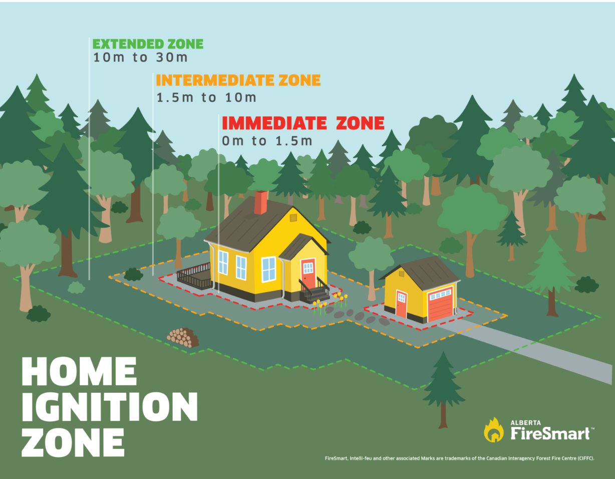

    - Flood Assessment – assess your property for flood risk and determine where high ground is on your land that would be suitable for keeping animals out of water.
    - Assess the location of fuel, chemical and fertilizer storage locations to determine if they add risks to livestock when you have evacuated.

  - Reduce the risk of surface fire on farm (grass/undergrowth fires).
    - Managing vegetation around fence lines, corral lines and ditches.
      - Unmanaged fence lines, corral lines and ditches can lead to a buildup of grass, weeds, and brush - excellent fuel for wildfires.
      - To prevent fires from starting, or spreading, manage the vegetation (for at least 100 metres in all directions) by mowing the areas and using herbicide/weed eater under the wires and between the posts.

    - Other areas
      - Granaries, barns, and outbuildings: Reduce the vegetation around buildings to lower the risk of wildfire.
      - Old corrals and unused corners of your yard: Manage these areas through mowing, grazing, weed eating, treating with herbicide and/or gravelling.
      - Around dugouts and other water sources: Keep these areas free of equipment, lumber, and other trash to provide access to the water for firefighters.
    - Managing feed storage
      - Dry bales are a magnet for sparks and embers. No matter how you store the bales, once ignited, they cause fires that spread rapidly and are difficult to control or extinguish. Fires in stored hay are usually the result of high heat or spontaneous combustion. (the main cause of spontaneous combustion is an excess of moisture in the bales).
      - Store bales a good distance from any structures to minimize the spread of fire to your house and outbuildings. The area between the bales and buildings should contain minimal vegetation - preferably mineral soil or gravel.
      - If you do have grass in this area, it's essential that it remain short.
    - Be FireSmart by storing your winter supply of bales in a few different locations to minimize loss should a fire occur. As well, if you use the bales closest to the house and out-buildings during feeding season, you will end up with a larger buffer in that area come spring.
    - Another important FireSmart practice is to clean up the old hay and straw that accumulates from broken bales and bale bottoms that freeze over the winter. You can do this by:
      - hauling it out onto the pasture for the livestock to pick through it.
      - spreading it over the field (like manure).
      - letting your livestock graze the leftover hay.

  - Evaluate livestock evacuation/relocation options.
    - Do you have some open pasture near to where the animals are which keeps them away from the hazard? Is there feed and water for at least 3 days?
    - Is there another farm/pasture nearby where you can arrange for temporary shelter/pasture?
    - For flood risks, is there land with high ground where animals can get away from the water?

  - Develop "shelter-in-place" options for livestock when they cannot leave.
    - Access to water – the watering source needs to be independent of power if possible. Failure of the power grid is common with fires and floods.
    - Extra feed - ensure that 3 days of feed is available, if appropriate.
    - Provide some room for animals to move – moving livestock to larger pens that are away from structures, or an open fire-proof pasture is ideal.
    - Plan to create impromptu fire breaks (using a disc or cultivator to break up the soil around the property or buildings). Most fires need some ground fuel to move, so creating a break in the dry grass, small bushes, etc. will help slow or redirect a fire.
    - Sprinkler plan – Fire Services recommend a wetting time of two hours prior to fire reaching the property for full saturation and effectiveness. If your water source for your sprinklers is dependent on electricity to operate (for example, it comes from a well), you may need to start the sprinklers early to ensure the ground and vegetation get wet.
    - Create a map of your operation and where the key sites are located
      - Livestock locations
      - Fertilizer and fuel storage
      - Chemical/Flammable liquids/compressed gas storage

Response
  - Pay attention to warnings.
    - AB Emergency Alert – for evacuation warnings
    - AB Wildfire Status app – for the status and location of fires in Alberta
    - Alberta Rivers app – for flood watches and warnings

  - Last minute adjustments and actions
    - Place extra feed in the location where animals are going to shelter (if necessary)
    - Open gates as planned to give livestock room to stay away from hazards.
    - Build/cultivate impromptu firebreak around the property and important buildings/pens/pastures. Make one or two passes around your yard and feed storage areas. On the map below the dashed line is where you would plan to cultivate a fire break. The green dot is a dugout with water.

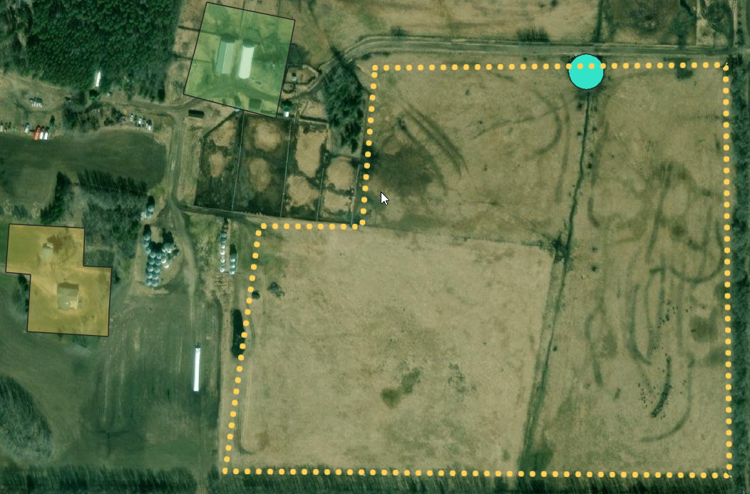

    - Set up sprinklers and start watering ground and vegetation around buildings.
    - Take pictures of property and livestock before departure as this will help you to identify livestock after the emergency if they get loose.
      - This will help to explain the level of damages to your insurance company if you need to make a claim.

  - Implement livestock evacuation if possible.
    - Notification to receiving site (if required) – let the owner/operator of the receiving site know that you are bringing the animals.
    - Implement transportation plan – Have the trucks/trailers/handlers start moving the livestock to be loaded and transported to the selected evacuation site.

  - Departure of humans (It is time for you and your family to evacuate!)
    - Power and gas shut-off to non-essential buildings.
    - Start sprinklers (if set up and not started already)

  - Request temporary re-entry to the evacuation zone from your municipality (County, Municipal District, Settlement or First Nation) when it is safe to do so. To check on animals and provide feed and water.

