The Great Twine Round-Up is coming to Alberta with $12,000 in cash prizes for 4-H clubs and ag charities!
Cleanfarms, through the ‘Alberta Ag-Plastic. Recycle-It! pilot program is hosting ‘The Great Twine Round-Up’; a new province-wide twine collection contest with four cash prizes of $3,000 each, for the winners’ 4-H club or an Alberta-based agricultural charity of choice.
Here's how to participate:
- Collect used plastic baler twine in the collection bags provided for free at participating collection sites and select County offices.
- Mark each bag with your 4-H club/district name and the date, if you’re participating on behalf of a 4-H club or full name/farm name and the date, if you’re participating individually.
- Drop off the bags at a participating collection site between November 1, 2024, and May 31, 2025, and snap a photo of your bags at the site!
- Submit your photo through the contest webpage to enter: greattwineroundup.ca

The more bags you drop off, the more entries you'll have. You’ll also be helping to keep used baler twine out of landfills and burn piles.

There will be four chances to win;
- One early-bird prize draw for a winning 4-H club/district in January.
- Two prize draws at the end of the contest for winning 4-H clubs/districts.
- One prize draw at the end of the contest for an independent entrant’s Alberta-based agricultural charity of choice.

For more information and full contest rules, visit the contest webpage: greattwineroundup.ca
‘The Great Twine Round-Up’ is part of the ‘Alberta Ag Plastic. Recycle it!’ pilot program, through which Alberta farmers return used plastic baler twine and grain bags for recycling. Last year, Cleanfarms recycled 673,000 kg of grain bags and 95,400 kg of twine through this pilot. Learn more about this program: https://cleanfarms.ca/alberta-ag-plastic-recycle-it-program-details/.

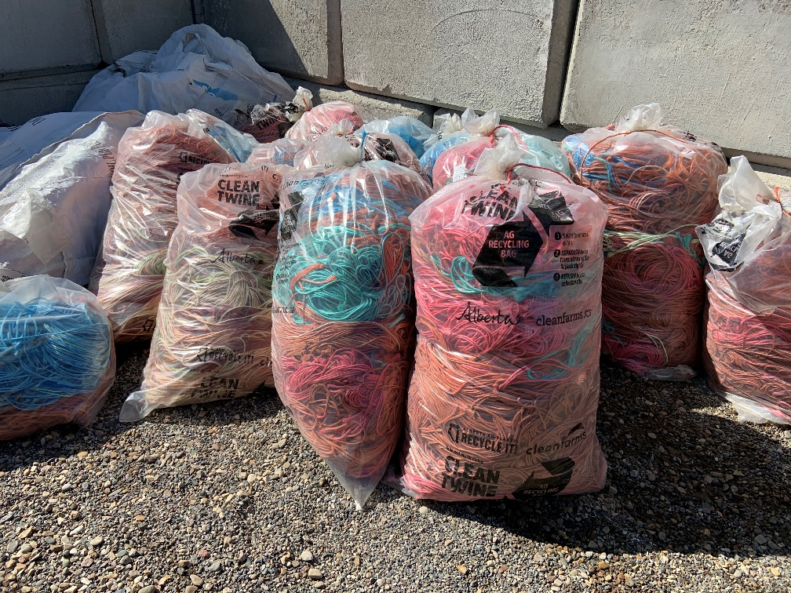
Used plastic baler twine ready for recycling at a collection site.

